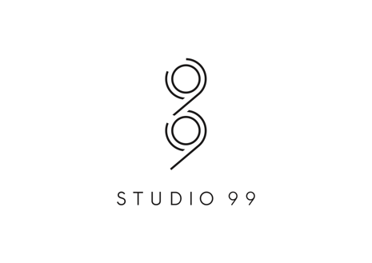

PRODUCTION MANAGER
JOB DESCRIPTION

Studio 99 is on the search for a talented Production Manager. Based at our head office in Gt Portland St, this position is an integral role to the exciting growth trajectory of Studio 99’s editorial content.

We’re looking for a driven; creatively minded, problem-solving and experienced Production Executive. This person will join our existing Studio99 team and will be working across premium documentary slate - from preparing initial budgets to delivering the project.

The successful candidate will have extremely strong technical production expertise, experience of managing complex documentary productions with A-List Talent, and will have a contact list of the best production talent.

The Ideal Candidate:
6+ years of the non-fictional content production experience.

Significant experience overseeing the planning, production, management and delivery of editorial content from pre-production, shoot, to post-production.

The ability to manage and develop a production team, building a robust schedule and juggling multiple projects simultaneously.

Knowledge of best practice workflows to drive efficiency.

Experience with all forms of production paperwork, licenses, model agreements and legal requirements.

An extensive contacts book and relationships with directors, producers, production companies & photographers, bring new partnerships to the business.

What you’ll do:
Using detailed knowledge of the production process, and experience in all aspects of video production (storyboarding, scripting, casting, location hunting, setting up production offices, budgeting, directing etc) to deliver exceptional documentaries.

Overseeing the production team and ensuring projects are delivered on-time and on-budget.

Ensuring the correct kit is to be used to achieve the right results.

Personal Profile:
The ability to work independently under pressure.

Quick learner and ability to adapt to fast paced nature of the job.

Good head for numbers.

Confident and assertive with a solution focused attitude.

Professional manner and behaviour.

Efficient, reliable and honest.

Ability to work flexibly to meet deadlines and willingness to work weekends or evenings if required.

Excellent written and verbal communication skills and an approachable personality.

